22 march 2019

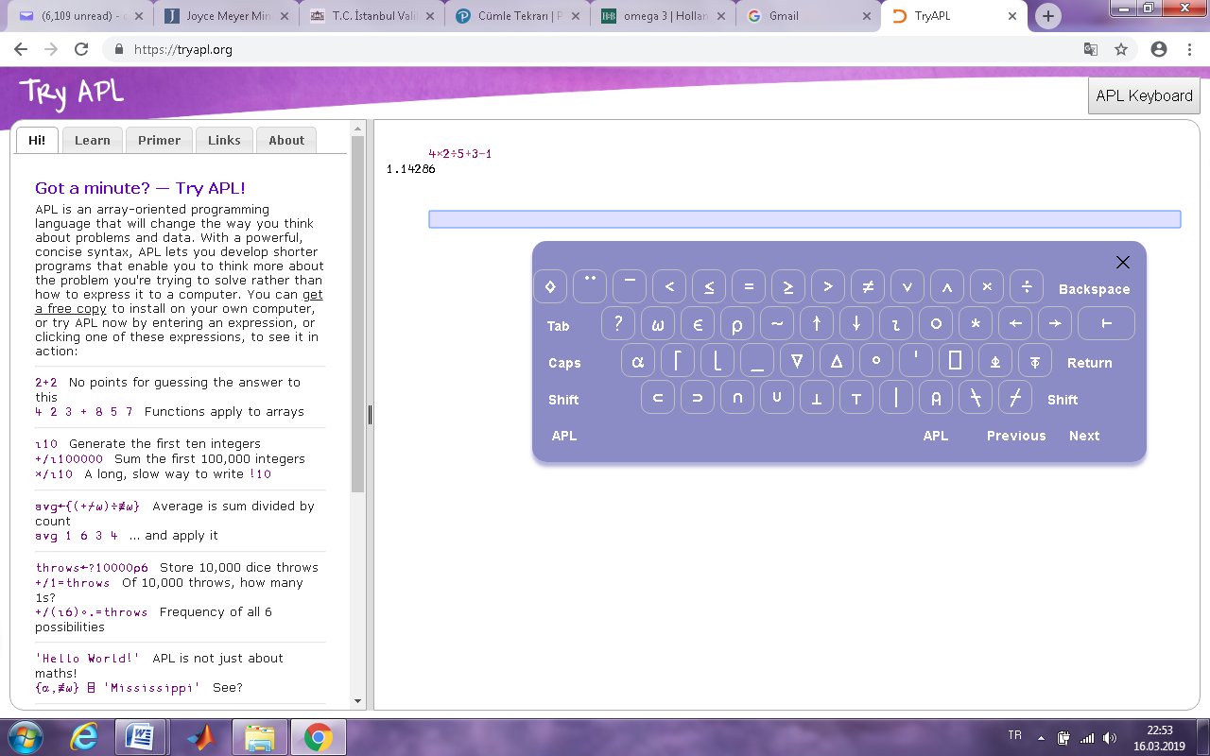LAB EXERCISE – 6

1) APL programming language calculates the expressions from right to left sequentially. Calculate the expression below by using a C-based programming language and by using APL (the compiler: <http://tryapl.org/>) Compare and explain the results. (multiplication sign is “x”, division sign is “÷” in APL, use APL keyboard, write the expression in the box as shown on the right side)

|  |  |
| --- | --- |
| a) 10-3+5-2=? | d) for x=3 and y=5 |
| b) 4+2*5=? |
| c) 2*5+4=? |

2) Run the Java code below and explain why result1/result2 are different and why before/after f value are different regarding operand evaluation order.

public class GlobalMembers

{ public static int b = 4, f = 5;

public static int fun1(int a)

{ a = 17;

b = b + 2;

return a;

}

public static int fun2()

{ f = f + 1;

return f;

}

public static void main(String args[])

{ int a = 6, d = 12, temp;

float result1, result2;

result1 = (fun1(a) + b) / (fun1(a) - d);

System.out.print("\n a=" + a + " b=" + b + " d=" + d);

System.out.print(" result1= " + result1);

temp = fun1(a);

result2 = (temp + b) / (temp - d);

System.out.print("\n a=" + a + " b=" + b + " d=" + d);

System.out.print(" temp= " + temp + " result2= " + result2);

System.out.print("\n before f = " + f);

f = f + fun2();

System.out.print("\n after f = " + f);

}

}

3) Write a Phyton to compare these two divisions ;c=a//b and d=a/b. (// Integer division operator). Assign integer (like a=5 and b=3)and real values (like a=5.0 and b=3.0) to a and b and explain the division results.